OUTPUT OF ALL CODING
OUTPUT 1
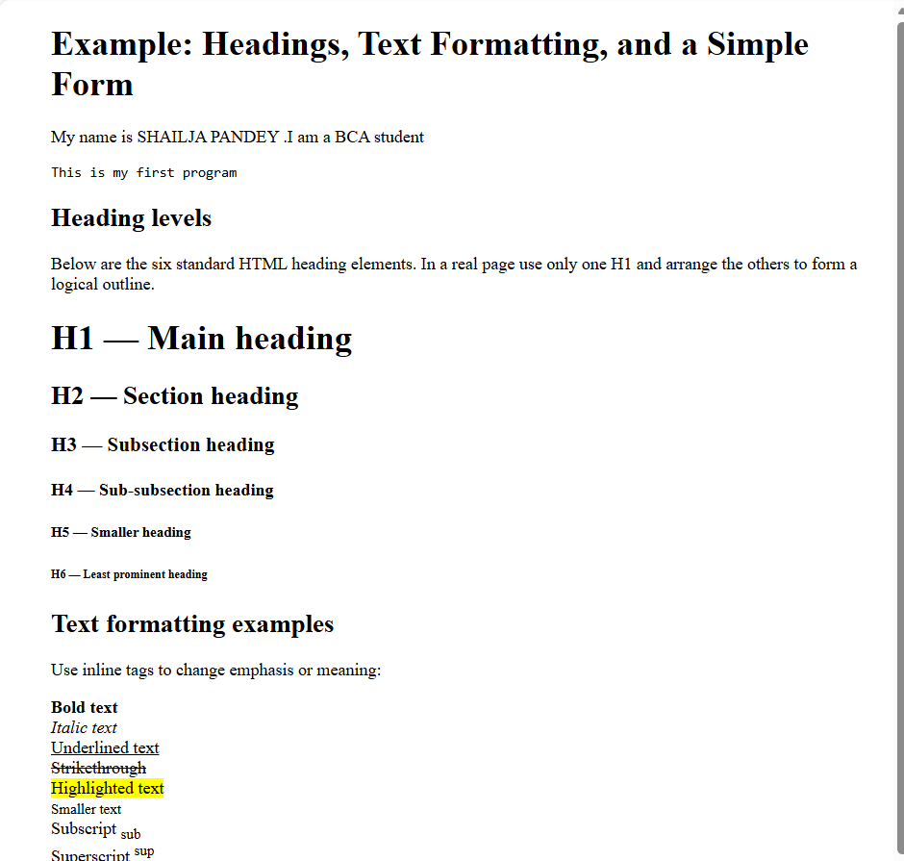

OUTPUT 2

OUTPUT 3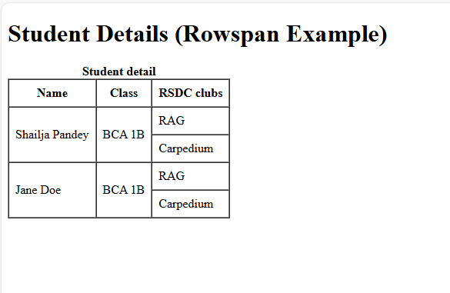
OUTPUT 4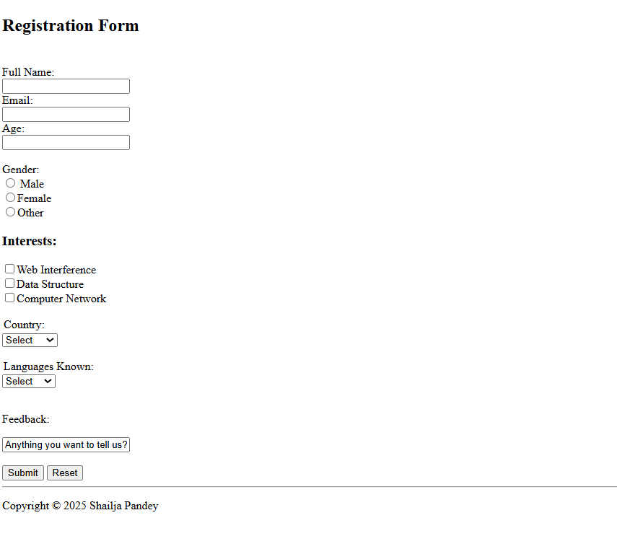

OUTPUT 5
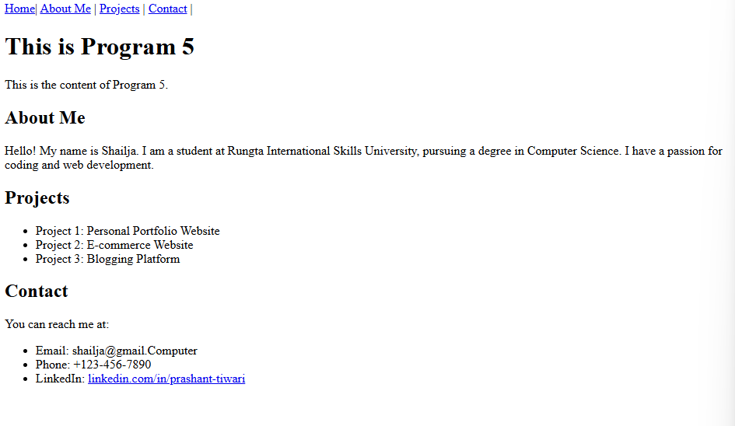
OUTPUT 6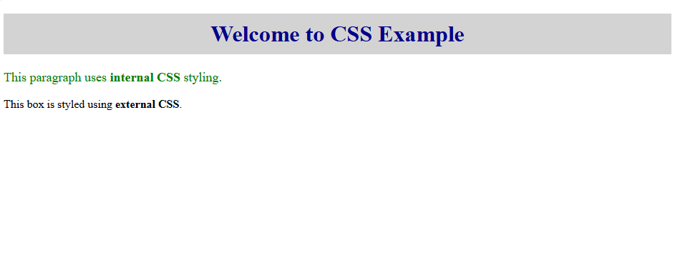
OUTPUT 7
OUTPUT 8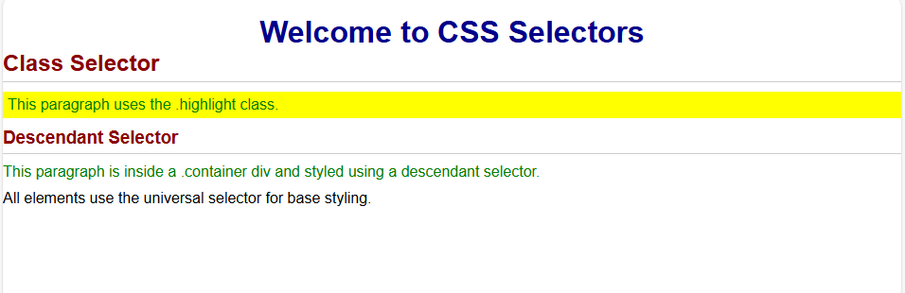
OUTPUT 9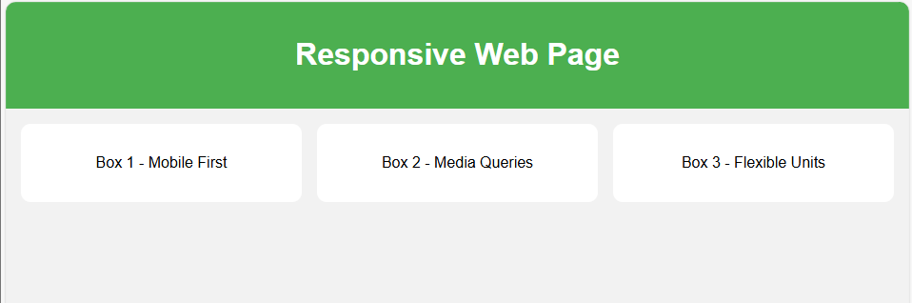
OUTPUT 10 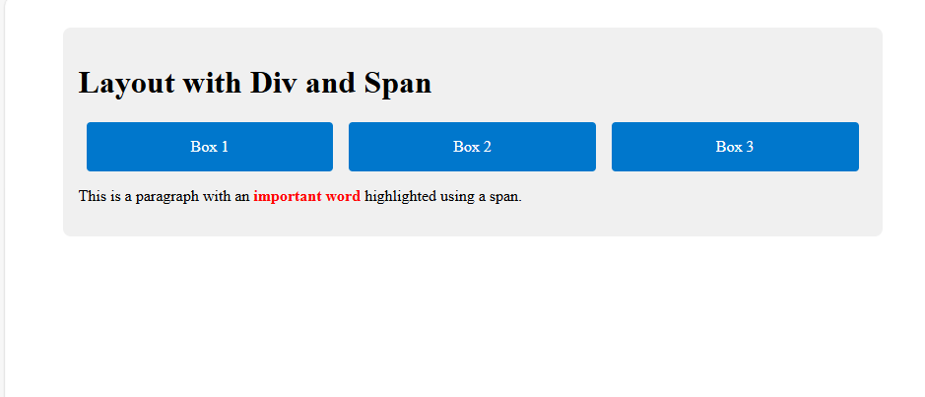OUTPUT 11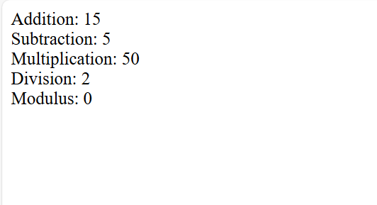
OUTPUT 12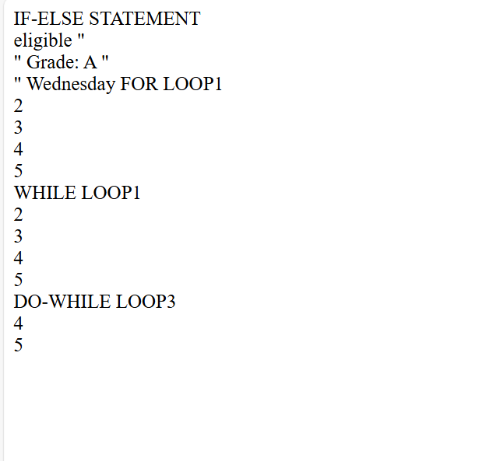
OUTPUT 13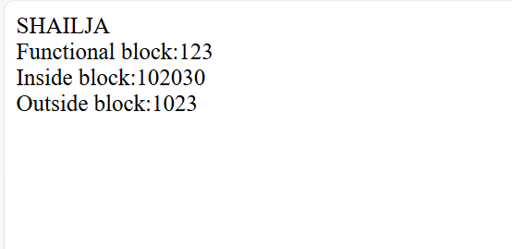
OUTPUT 14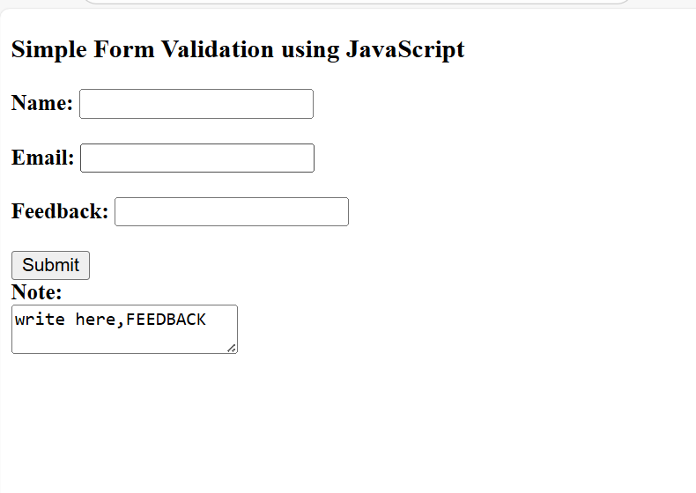

OUTPUT 15
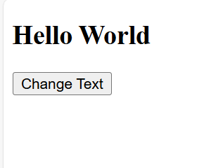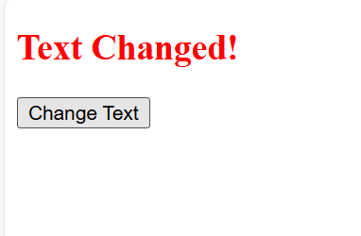
OUTPUT 16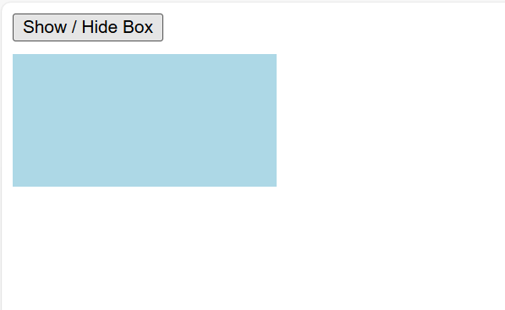
OUTPUT 17
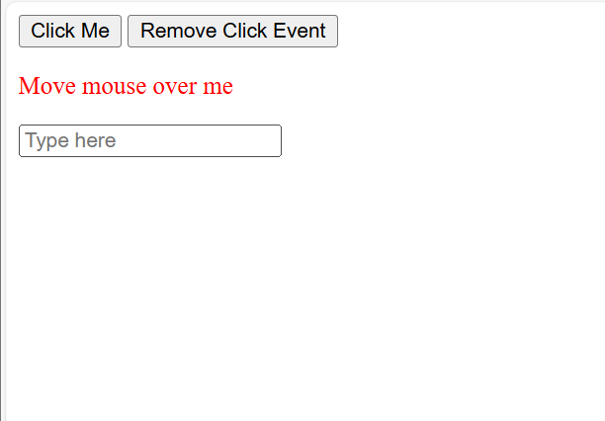
OUTPUT 18

OUTPUT 19
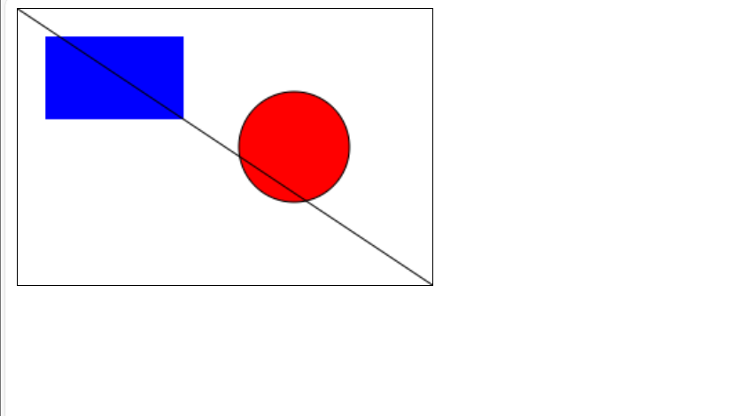
ANSWER 20
PART 1: Initialize Git, Commit & Push to GitHub
Step 1: Create a project folder
my-portfolio
(Add your index.html, style.css, script.js, etc.)
Step 2: Initialize Git
.git init
Step 3: Check status
git status
Step 4: Add files to staging
git add .
Step 5: Commit changes
git commit -m "Initial commit - Portfolio website"
Step 6: Create a GitHub repository
Go to GitHub → New Repository
Repository name: portfolio or my-portfolio
Public ✔
Do NOT add README
Click Create Repository
Step 7: Connect local repo to GitHub
git branch -M main
git remote add origin https://github.com/USERNAME/REPOSITORY_NAME.git
Step 8: Push code to GitHub
git push -u origin main
Your code is now on GitHub!
PART 2: Deploy Portfolio on GitHub Pages
Step 1: Go to repository settings
Open GitHub repo
Click Settings
Go to Pages
Step 2: Configure GitHub Pages
Source: Deploy from a branch
Branch: main
Folder: /root
Click Save
Step 3: Get live URL
After 1–2 minutes:
https://USERNAME.github.io/REPOSITORY_NAME/
Your portfolio is live!
PART 3: Deploy Portfolio on Netlify (Alternative & Professional)
Method 1: Drag & Drop (Easy)
Go to https://www.netlify.com
Login with GitHub
Drag your project folder into Netlify
Done
Method 2: GitHub Auto Deploy (Recommended)
Netlify → Add new site
Import from Git
Select GitHub

